**Hybrid Topology**

Assignment 4

**COMSATS University Islamabad**

Sahiwal Campus



**Usama Sarwar**

FA17-BS(CS)-090-B

**Ms Anum**

CNN Lab

December 03, 2019

HYBRID TOPOLOGY

Hybrid topology is an interconnection of two or more basic network topologies, each of which contains its own nodes. The resulting interconnection allows the nodes in a given basic topology to communicate with other nodes in the same basic topology as well as those in other basic topologies within the hybrid topology. Advantages of a hybrid network include increased flexibility as new basic topologies can easily be added or existing ones removed and increased fault tolerance.

# Star-Wired Ring Network Topology

In a star-wired ring hybrid topology, a set of star topologies are connected by a ring topology as the adjoining topology. Joining each star topology to the ring topology is a wired connection.

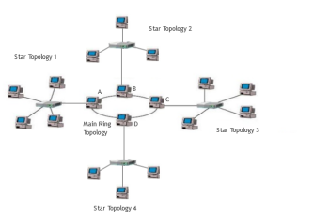

Figure 1 is a diagrammatic representation of the star-wired ring topology:

Star-Wired Ring Topology

In Figure 1, individual nodes of a given star topology like Star Topology 1 are interconnected by a central switch which in turn provide an external connection to other star topologies through a node A in the main ring topology.

Information from a given star topology reaching a connecting node in the main ring topology like A flows either in a bidirectional or unidirectional manner. A bidirectional flow will ensure that a failure in one node of the main ring topology doesn't lead to the complete breakdown of information flow in the main ring topology.

# Star-Wired Bus Network Topology

A star-wired bus topology is made up of a set of star topologies interconnected by a central bus topology. Joining each star topology to the bus topology is a wired connection.

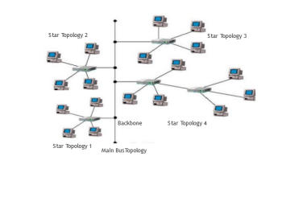

Figure 2 is a diagrammatic representation of the star-wired bus topology:

Star-Wired Bus Network Topology

In this setup, the central bus topology provides a backbone connection that interconnects the individual star topologies. The backbone, in this case, is a wired connection.

# Hierarchical Network Topology

Hierarchical network topology is structured in different levels as a hierarchical tree. For this reason, it's also referred to as tree network topology.



Figure 3 shows a diagrammatic representation of the Hierarchical network topology:

Hierarchical Network Topology

Connection of the lower levels like level 2 to higher levels like level 1 is made through wired connection. The topmost level, level 0, contains the parent (root) node. The second level, level 1 contains the child nodes which in turn have child nodes in level 3. All the nodes in a given level have a higher parent node except for the nodes at the top most level. The nodes at the bottom most level are called leaf nodes, since they are peripheral and are parent to no other node. At the basic level, a tree network topology is a collection of star network topologies arranged in different levels. Each level, including the top most, can contain one or more nodes.